Chain line and offsets
Draw to a 1:100 scale the building outline using the dimensions given (rectangular offests & chain line).
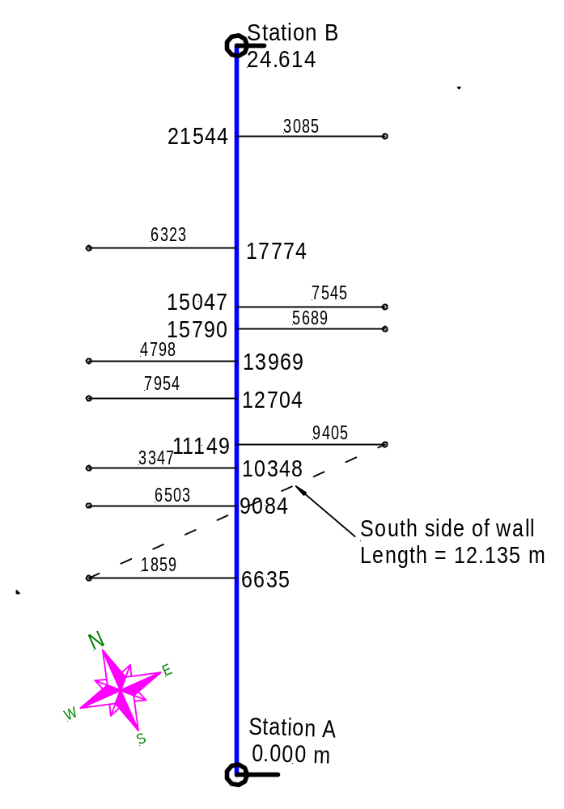

file: polar-cord-test.skf

